Youth services review
Survey for parents and carers of young people aged 10 to 25.

We are undertaking a review of the services we deliver to young people who live, work and play in Knox. This is part of our commitment to continually review and refine our services.

Your feedback will be considered as we review the services we deliver for young people across Knox going forward.

This survey is for parents and carers of young people aged 10 to 25, there is separate surveys for young people themselves, service providers and everyone else. Everyone who gets involved can go into the draw to win a voucher for an amazing local experience.

You can find out more about this project and to complete the survey online, visit HaveYourSay.knox.vic.gov.au/YouthServicesReview

You can also call Youth Services on 9298 8000 or email YouthServicesReview@knox.vic.gov.au

What suburb do you have the strongest connection with in Knox?
For example, where you live, study, work, play sport or hang out in Knox.
☐ Bayswater
☐ Boronia
☐ Ferntree Gully
☐ Knoxfield
☐ Lysterfield
☐ Rowville
☐ Scoresby
☐ The Basin
☐ Upper Ferntree Gully
☐ Wantirna
☐ Wantirna South

What is the age of the young person in your family / care?
If there is more than one person, tick all that apply.
☐ 10 to 12 years
☐ 13 to 17 years
☐ 18 to 25 years

How do you think Council should support young people in Knox?
There is a mix of ways we can support young people in Knox. Thinking about what type of services Council’s youth services should deliver, rank these options in order of importance to you.
Number from 1 to 5, with 1 being most important.

_____ Deliver support programs and activities, for example young parents program, LGBTIQ+ programs.

_____ Deliver social programs and activities , for example Freeza Program, school holiday activities

_____ Partner with community organisations to deliver services for example LGBTIQ+ programs with Headspace, Dungeons and Dragons group with Your Library

_____ Provide support to community organisations that deliver youth programs, for example promoting programs provided by others.

_____ Advocating on behalf of the desires and needs of young people.

What services would you like Council to deliver to support you as a parent / carer?

What time and day would you like activities / programs to be delivered?
Choose your top three.
☐ Weekday mornings
☐ Weekday afternoons
☐ Weekday evenings
☐ Weekend mornings
☐ Weekend afternoons
☐ Weekend evenings
☐ School holidays
☐ University holidays

Youth Hive
The next questions are about the Youth Hive.
The Youth Hive is Council’s new dedicated space for young people aged 10 to 25 years old and is a place for young people to connect, study, relax and play. The Youth Hive is located in the brand new Knox Library at Knox Westfield.

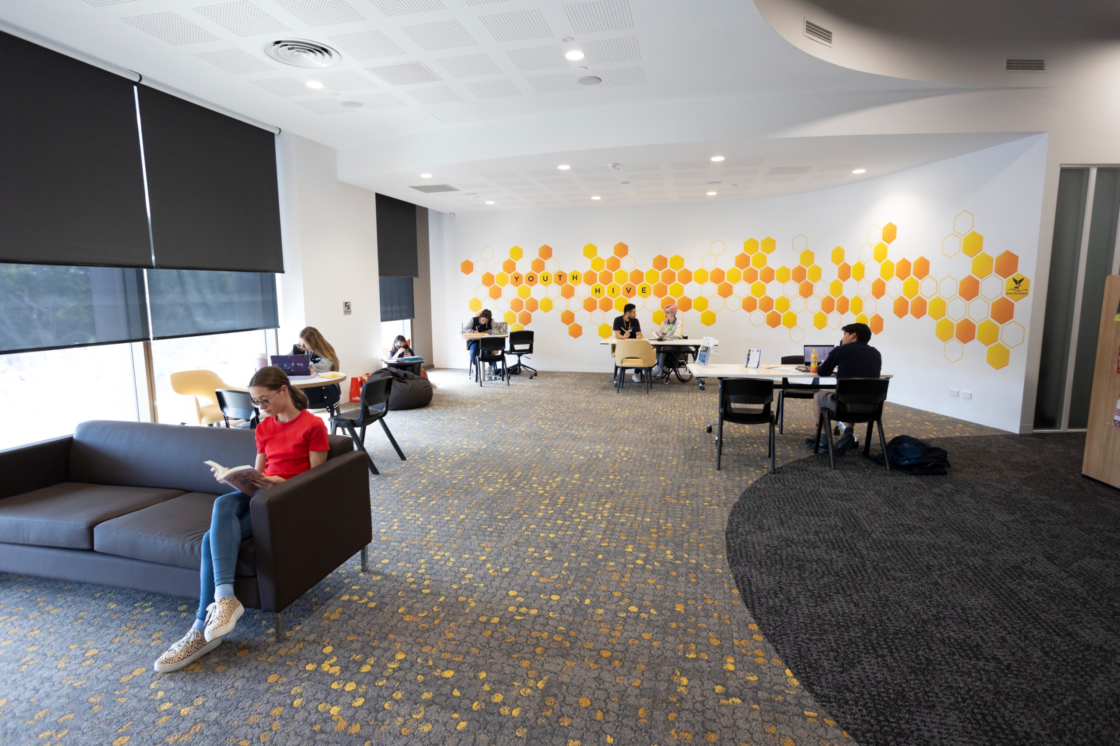
[Image: Young people sitting in a room in small groups or alone. They are on devices or talking. There is a honeycomb pattern on the wall at the back of the room.]

What would you like to see in the Youth Hive? A place for young people to:
Select as many options as you like.
☐ Connect with other young people
☐ Connect with youth workers
☐ Study
☐ Relax
☐ Play
☐ Participate in an organised program/activity
☐ None, I will not visit the Youth Hive

Are there any other comments you would like to share before you finish?

Would you like to go in the draw to win a voucher for a local experience?
Everyone who provides feedback can go in the draw to win a voucher.
You will need to share your contact information, include name and the best way for us to contact you if you win. We will only use this information to contact you if you win a prize.
Full name ____________________________________

Email or phone number ____________________________________

Conditions apply to the competition. For more information call 9298 8000 or visit HaveYourSay.knox.vic.gov.au/Have-Your-Say-and-Win

